UNIT-IV
SEQUENTIAL CIRCUITS
Unlike Combinational Logic circuits that change state depending upon the actual signals being applied to their inputs at that time, Sequential Logic circuits have some form of inherent “Memory” built in.

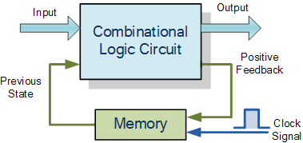

The word “Sequential” means that things happen in a “sequence”, one after another and in Sequential Logic circuits, the actual clock signal determines when things will happen next. Simple sequential logic circuits can be constructed from standard Bistable circuits such as: Flip-flops, Latches and Counters and which themselves can be made by simply connecting together universal NAND GATES and/or NOR GATES in a particular combinational way to produce the required sequential circuit.
This means that sequential logic circuits are able to take into account their previous input state as well as those actually present, a sort of “before” and “after” effect is involved with sequential circuits.
In other words, the output state of a “sequential logic circuit” is a function of the following three states, the “present input”, the “past input” and/or the “past output”. Sequential Logic circuits remember these conditions and stay fixed in their current state until the next clock signal changes one of the states, giving sequential logic circuits “Memory”.
Sequential logic circuits are generally termed as two state or bi-stable devices which can have their output or outputs set in one of two basic states, a logic level “1” or a logic level “0” and will remain “latched” (hence the name latch) indefinitely in this current state or condition until some other input trigger pulse or signal is applied which will cause the bi-stable to change its state once again.

SR Flip-Flop
The SR flip-flop, also known as a SR Latch, can be considered as one of the most basic sequential logic circuit possible. This simple flip-flop is basically a one-bit memory bi-stable device that has two inputs, one which will “SET” the device (meaning the output = “1”), and is labelled S and another which will “RESET” the device (meaning the output = “0”), labelled R.
Then the SR description stands for “Set-Reset”. The reset input resets the flip-flop back to its original state with an output Q that will be either at a logic level “1” or logic “0” depending upon this set/reset condition.
A basic NAND gate SR flip-flop circuit provides feedback from both of its outputs back to its opposing inputs and is commonly used in memory circuits to store a single data bit. Then the SR flip-flop actually has three inputs, Set, Reset and its current output Q relating to it’s current state or history. The term “Flip-flop” relates to the actual operation of the device, as it can be “flipped” into one logic Set state or “flopped” back into the opposing logic Reset state.

The NAND Gate SR Flip-Flop:
The simplest way to make any basic single bit set-reset SR flip-flop is to connect together a pair of cross-coupled 2-input NAND gates as shown, to form a Set-Reset Bistable also known as an active LOW SR NAND Gate Latch, so that there is feedback from each output to one of the other NAND gate inputs. This device consists of two inputs, one called the Set, S and the other called the Reset, R with two corresponding outputs Q and its inverse or complement Q (not-Q) as shown below.

The Basic SR Flip-flop
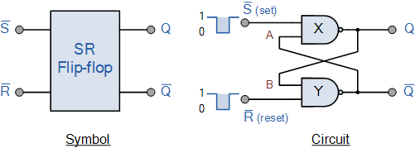

The Set State
Consider the circuit shown above. If the input R is at logic level “0” (R = 0) and input S is at logic level “1” (S = 1), the NAND gate Y has at least one of its inputs at logic “0” therefore, its output Q must be at a logic level “1” (NAND Gate principles). Output Q is also fed back to input “A” and so both inputs to NAND gate X are at logic level “1”, and therefore its output Q must be at logic level “0”.
Again NAND gate principals. If the reset input R changes state, and goes HIGH to logic “1” with S remaining HIGH also at logic level “1”, NAND gate Y inputs are now R = “1” and B = “0”. Since one of its inputs is still at logic level “0” the output at Q still remains HIGH at logic level “1” and there is no change of state. Therefore, the flip-flop circuit is said to be “Latched” or “Set” with Q = “1” and Q = “0”.

Reset State
In this second stable state, Q is at logic level “0”, (not Q = “0”) its inverse output at Q is at logic level “1”, (Q = “1”), and is given by R = “1” and S = “0”. As gate X has one of its inputs at logic “0” its output Q must equal logic level “1” (again NAND gate principles). Output Q is fed back to input “B”, so both inputs to NAND gate Y are at logic “1”, therefore, Q = “0”.
If the set input, S now changes state to logic “1” with input R remaining at logic “1”, output Q still remains LOW at logic level “0” and there is no change of state. Therefore, the flip-flop circuits “Reset” state has also been latched and we can define this “set/reset” action in the following truth table.

Truth Table for this Set-Reset Function
State | S | R | Q | Q | Description
Set | 1 | 0 | 0 | 1 | Set Q » 1
Set | 1 | 1 | 0 | 1 | no change
Reset | 0 | 1 | 1 | 0 | Reset Q » 0
Reset | 1 | 1 | 1 | 0 | no change
Invalid | 0 | 0 | 1 | 1 | Invalid Condition

It can be seen that when both inputs S = “1” and R = “1” the outputs Q and Q can be at either logic level “1” or “0”, depending upon the state of the inputs S or R BEFORE this input condition existed. Therefore the condition of S = R = “1” does not change the state of the outputs Q and Q.
However, the input state of S = “0” and R = “0” is an undesirable or invalid condition and must be avoided. The condition of S = R = “0” causes both outputs Q and Q to be HIGH together at logic level “1” when we would normally want Q to be the inverse of Q. The result is that the flip-flop looses control of Q and Q, and if the two inputs are now switched “HIGH” again after this condition to logic “1”, the flip-flop becomes unstable and switches to an unknown data state based upon the unbalance as shown in the following switching diagram.

S-R Flip-flop Switching Diagram
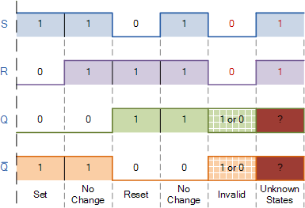
This unbalance can cause one of the outputs to switch faster than the other resulting in the flip-flop switching to one state or the other which may not be the required state and data corruption will exist. This unstable condition is generally known as its Meta-stablestate.
Then, a simple NAND gate SR flip-flop or NAND gate SR latch can be set by applying a logic “0”, (LOW) condition to its Set input and reset again by then applying a logic “0” to its Reset input. The SR flip-flop is said to be in an “invalid” condition (Meta-stable) if both the set and reset inputs are activated simultaneously.
As we have seen above, the basic NAND gate SR flip-flop requires logic “0” inputs to flip or change state from Q to Q and vice versa. We can however, change this basic flip-flop circuit to one that changes state by the application of positive going input signals with the addition of two extra NAND gates connected as inverters to the S and R inputs as shown.
JK FLIP-FLOP:
INTRODUCTION:
JK flip – flop is named after Jack Kilby, the electrical engineer who invented IC. A JK flip – flop is called a Universal Programmable flip – flop because, using its inputs J, K Preset and Clear, function of any other flip – flop can be imitated.
A JK flip – flop is the modification of SR flip – flop with no illegal state. In this the J input is similar to the SET input of SR flip – flop and the K input is similar to the RESET input of SR flip – flop. The symbol of JK flip – flop is shown below.
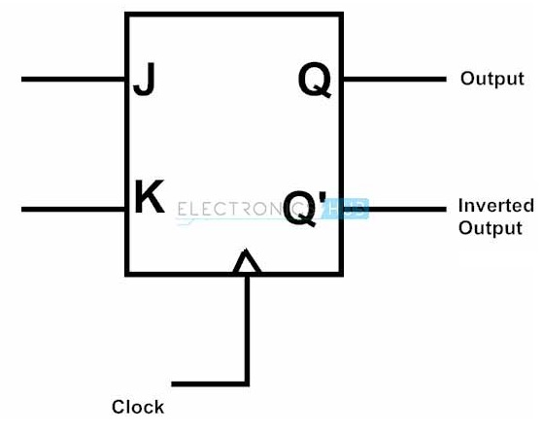

JK flip flop Logic Diagram
JK flip – flop logic diagram is shown in the below figure. As said before, JK flip – flop is a modified version of SR flip – flop. Logic diagram consists of three input NAND gates replacing the two input NAND gates in SR flip – flop and the inputs are replaced with J and K from S and R.
The design of the JK flip – flop is such that the three inputs to one NAND gate are J, clock signal along with a feedback signal from Q’ and the three inputs to the other NAND are K, clock signal along with a feedback signal from Q. This arrangement eliminates the indeterminate state in SR flip – flop.
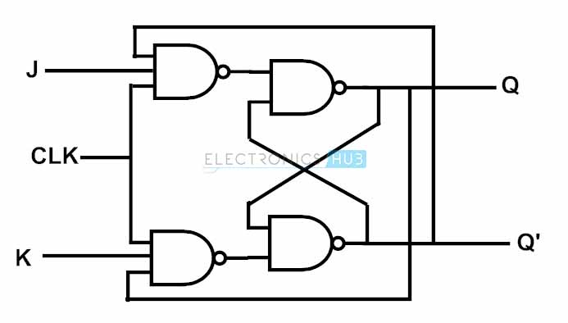

Truth Table
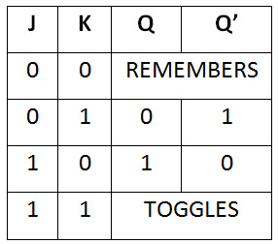

Operation

Case 1 : When both the inputs J and K are LOW, then Q returns its previous state value i.e. it holds the previous data.
When we apply a clock pulse to the J K flip flop and the J input is low then irrespective of the other NAND gates, the NAND gate-1 output becomes HIGH. In the same manner, if the K input is low then output of NAND gate-2 is also HIGH. So thus the output remains in the same state i.e. no change in the state of flip flop.

Case 2 : When J is LOW and K is HIGH, then flip flop will be in Reset state i.e. Q = 0, Q’ = 1.
When we apply a clock pulse to the J K flip flop and the inputs are J is low and K is high the output of the NAND gate connected to J input becomes 1. Then Q becomes 0. This will reset the flip flop again to its previous state. So the Flip flop will be in RESET state.

Case 3 : When J is HIGH and K is LOW, then flip – flop will be in Set state i.e. Q = 1, Q’ = 0
When we apply a clock pulse to the J K flip flop and the inputs are J is high and K is low the output of the NAND gate connected to K input becomes 1. Then Q’ becomes 0. This will set the flip flop with the high clock input. So the Flip flop will be in SET state.

Case 4 : When both the inputs J and K are HIGH,

Flip – flop is in Toggle state. This means that the output will complement of the previous state.

Truth Table
The truth table of JK flip – flop is shown below.
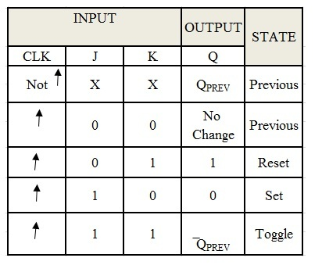

D Flip Flop:
The circuit diagram and truth table is given below.
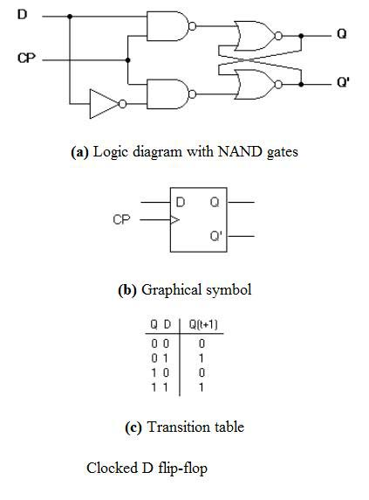

D flip flop is actually a slight modification of the above explained clocked SR flip-flop. From the figure you can see that the D input is connected to the S input and the complement of the D input is connected to the R input. The D input is passed on to the flip flop when the value of CP is ‘1’. When CP is HIGH, the flip flop moves to the SET state. If it is ‘0’, the flip flop switches to the CLEAR state.

T Flip Flop:

This is a much simpler version of the J-K flip flop. Both the J and K inputs are connected together and thus are also called a single input J-K flip flop. When clock pulse is given to the flip flop, the output begins to toggle. Here also the restriction on the pulse width can be eliminated with a master-slave or edge-triggered construction.
The circuit and truth table below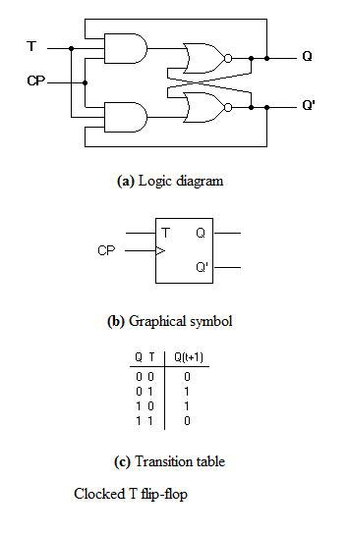
MASTER-SLAVE FLIP-FLOP:
Master-slave flip flop is designed using two separate flip flops. Out of these, one acts as the master and the other as a slave. The figure of a master-slave J-K flip flop is shown below.
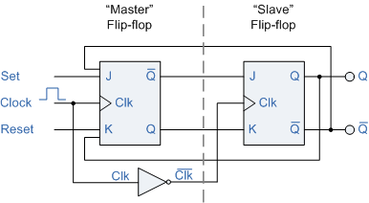
Master Slave Flip Flop
From the above figure you can see that both the J-K flip flops are presented in a series connection. The output of the master J-K flip flop is fed to the input of the slave J-K flip flop. The output of the slave J-K flip flop is given as a feedback to the input of the master J-K flip flop. The clock pulse [Clk] is given to the master J-K flip flop and it is sent through a NOT Gate and thus inverted before passing it to the slave J-K flip flop.

Working
When Clk=1, the master J-K flip flop gets disabled. The Clk input of the master input will be the opposite of the slave input. So the master flip flop output will be recognized by the slave flip flop only when the Clk value becomes 0. Thus, when the clock pulse males a transition from 1 to 0, the locked outputs of the master flip flop are fed through to the inputs of the slave flip-flop making this flip flop edge or pulse-triggered. To understand better take a look at the timing diagram illustrated below.
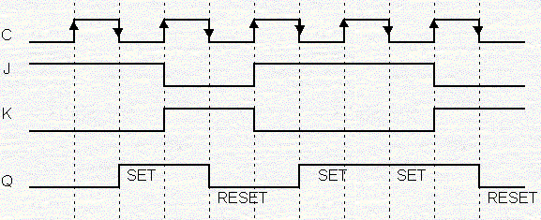
Master Slave J-K Flip Flop Timing Diagram
Thus, the circuit accepts the value in the input when the clock is HIGH, and passes the data to the output on the falling-edge of the clock signal. This makes the Master-Slave J-K flip flop a Synchronous device as it only passes data with the timing of the clock signal

